Creating a Private S3 Bucket on AWS

Objectives:
- Create a bucket in Amazon S3
- Add an object to a bucket
- Manage access permissions on an object and a bucket
- Create a bucket policy
- Use bucket versioning

Step 1 — Create the S3 Bucket General Configuration
Navigate to Amazon S3 in the AWS Console and click Create bucket. Set the bucket name to aws-mnv-26 with General purpose type and Global namespace.

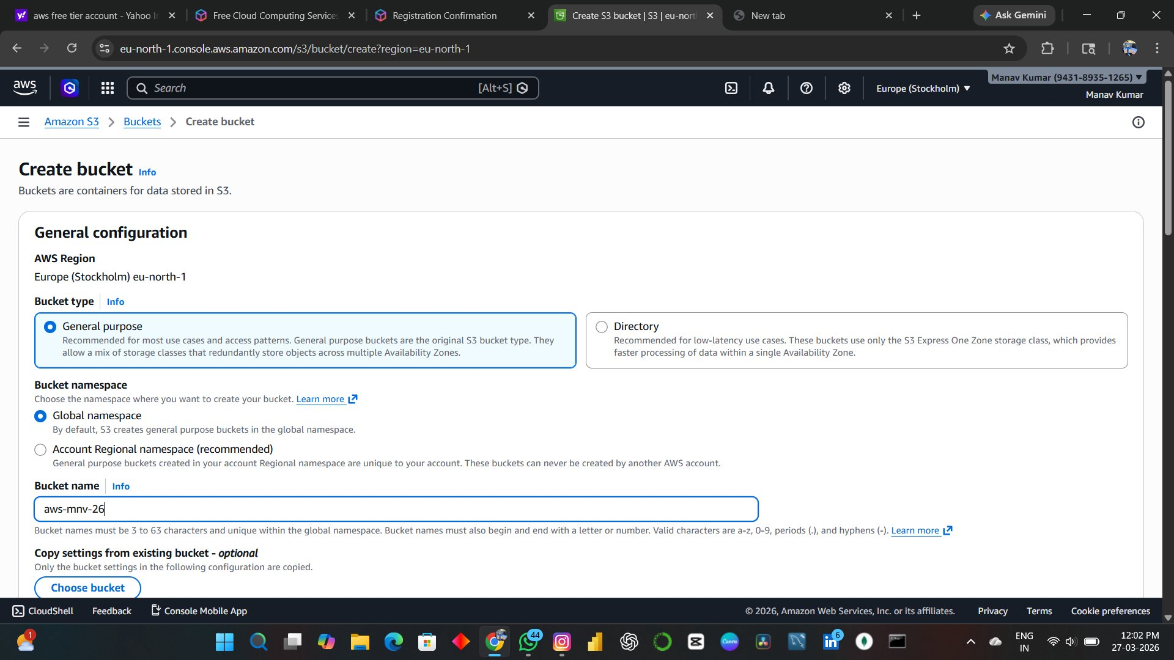

Step 2: Block Public Access Settings
Under Block Public Access settings, keep Block all public access enabled. This ensures no public internet access is granted to the bucket or any of its objects.

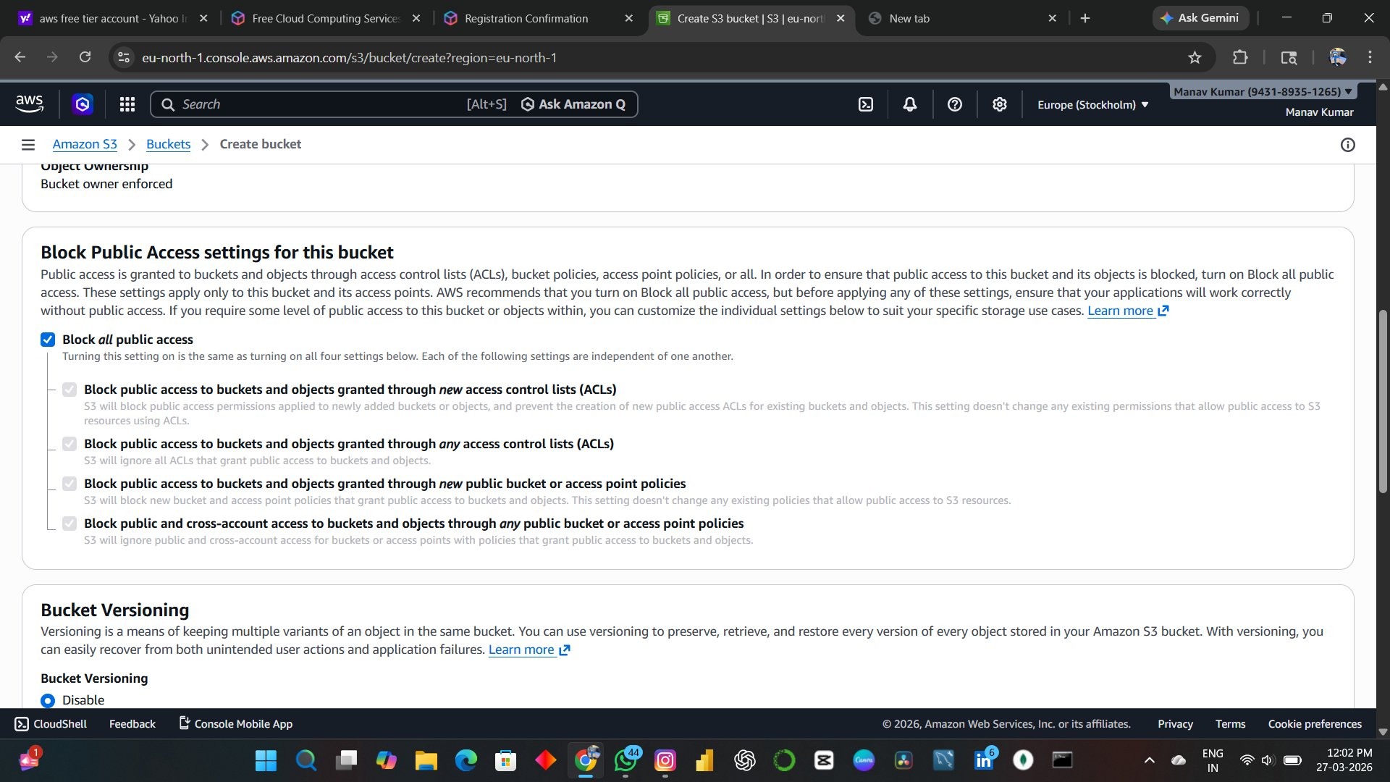

Step 3:Default Encryption
Server-side encryption is automatically applied to all new objects.

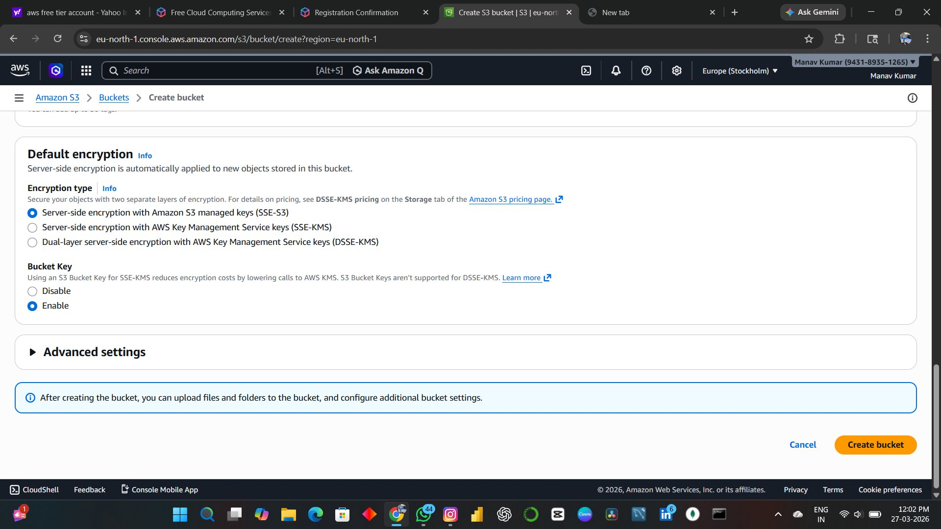

Step 4 — Upload an Object
Navigate into aws-mnv-26 and click Upload. Select image0.jpeg and confirm the upload.

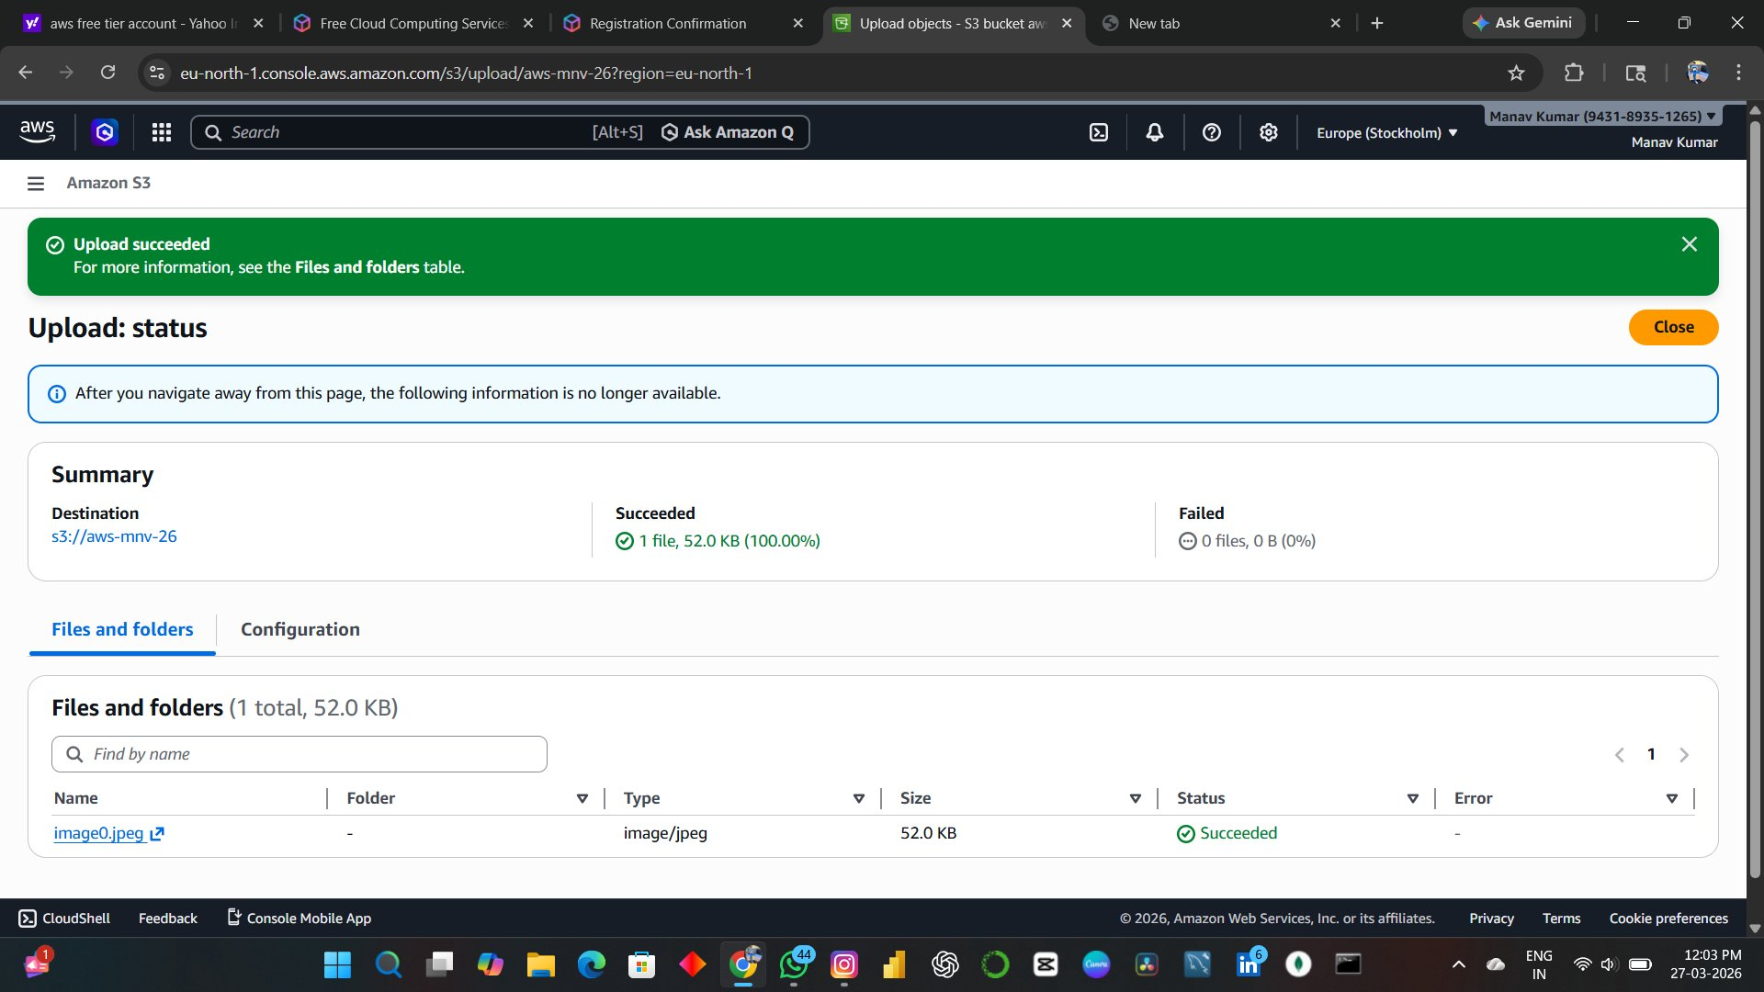

Step 5 — View Object Details
Click on image0.jpeg in the bucket to open the Object overview panel and inspect its properties.

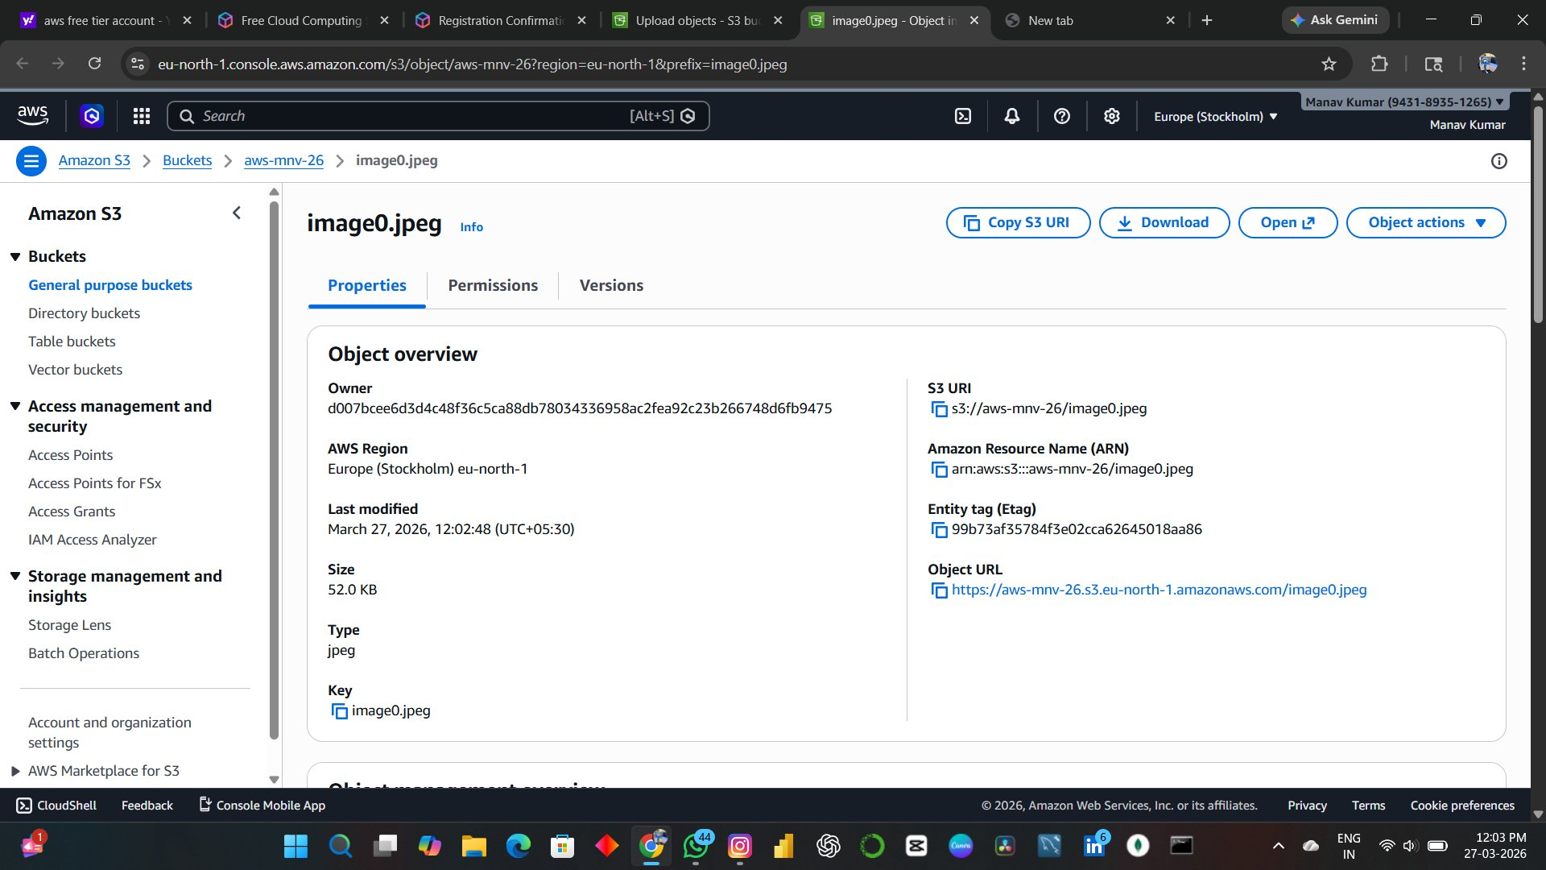

Step 6 — Delete the Object
Select image0.jpeg in the bucket, click Object actions > Delete, type 'permanently delete' to confirm, then click Delete objects.

